Copyright for test papers and marking guides remains with West Australian Test Papers.
Test papers may only be reproduced within the purchasing school according to the advertised Conditions of Sale.
Test papers should be withdrawn after use and stored securely in the school until Friday 4th December 2015.



SEMESTER TWO

MATHEMATICS
SPECIALIST
UNITS 1 & 2

2015

SOLUTIONS
Calculator−free Solutions

1. (a) 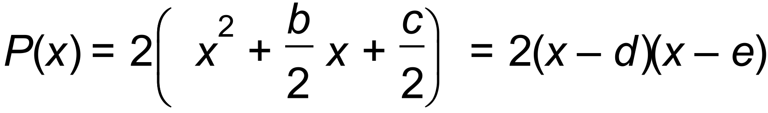 ✓
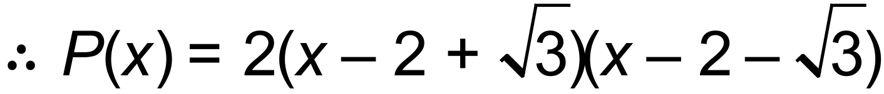 ✓

(b) ✓
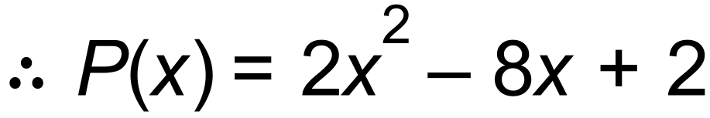 ✓
hence, 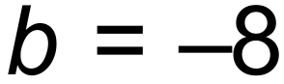 and 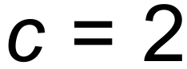 ✓ [5]

2. (a) 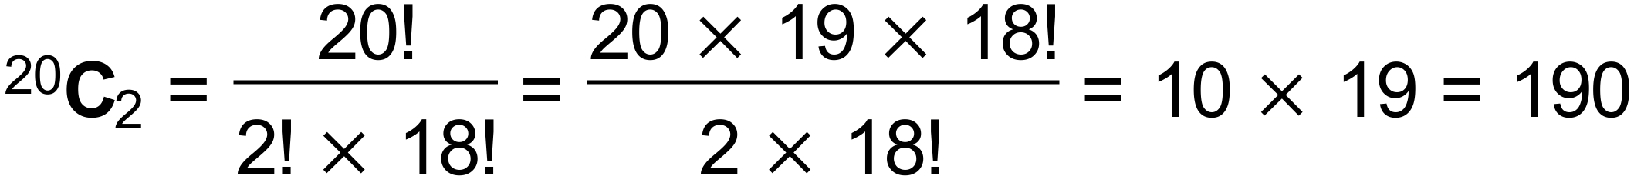 ✓✓
(b) ✓✓✓
(c) ✓ [6]

3. (a) 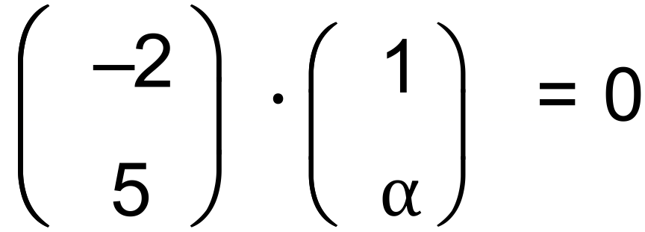
 ⇒ 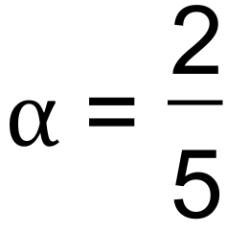 ✓
(b) 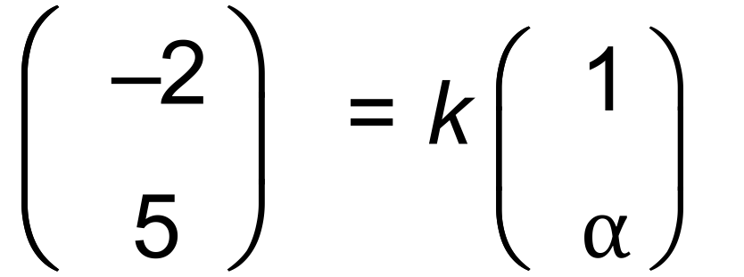 ⇒ 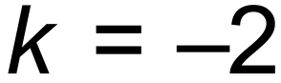 ✓
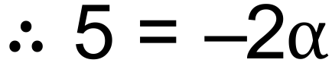 ⇒ 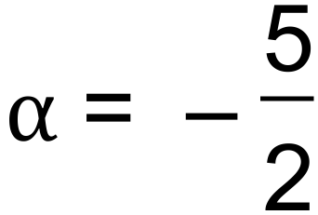 ✓
(c) 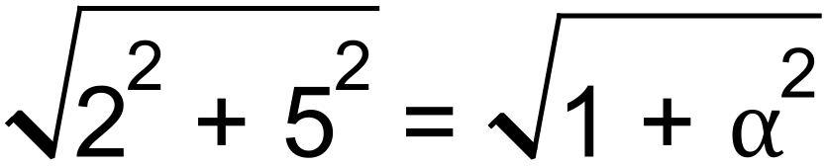 ✓
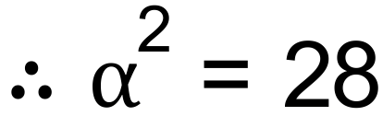 ⇒ 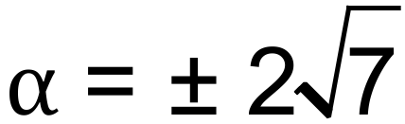 ✓
(d) 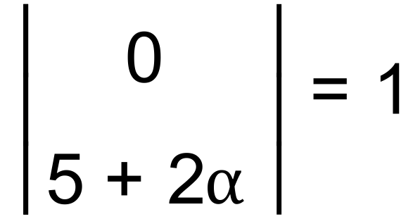 ⇒ 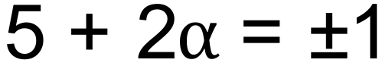 ⇒ 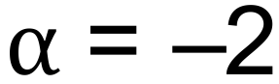 or 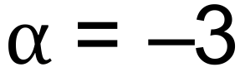 ✓✓ [7]

4. (a) (i) Since 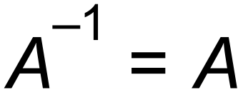 then 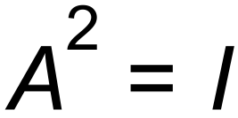
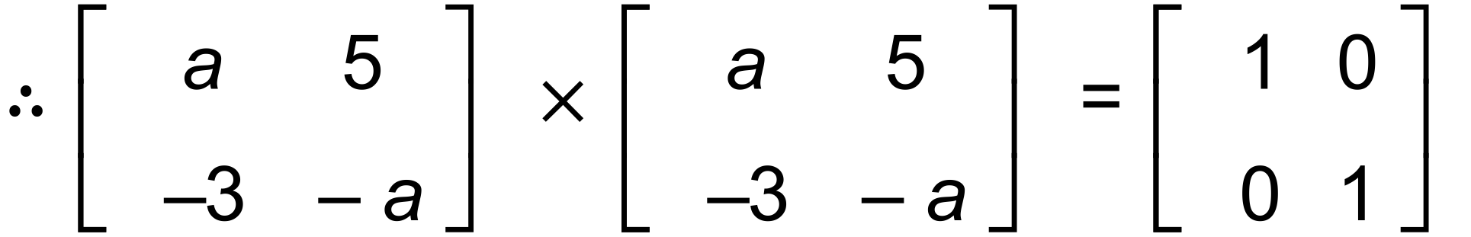 ✓
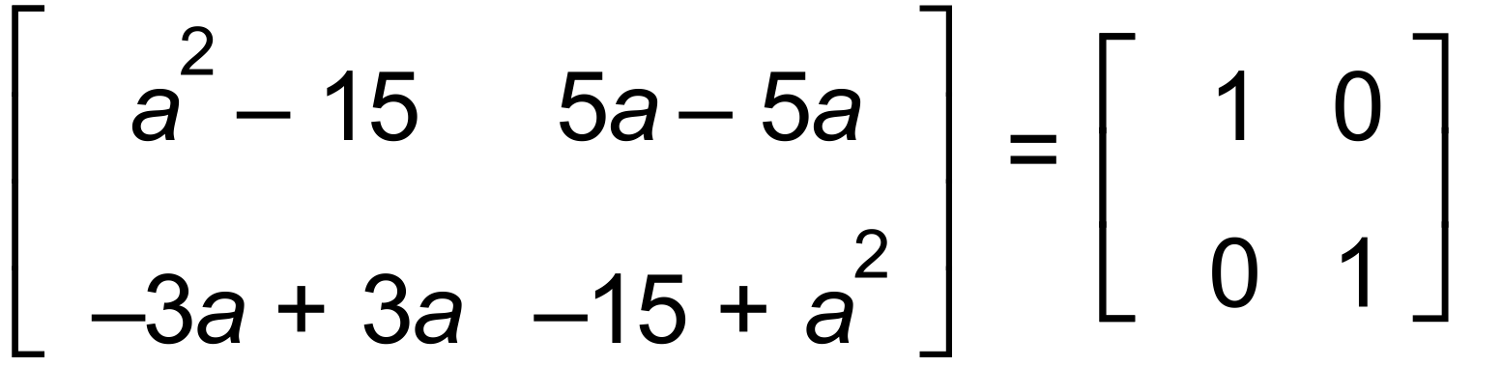
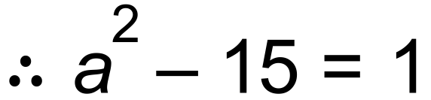 hence 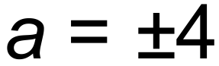 ✓✓

4. (a) (ii) for 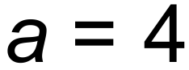, 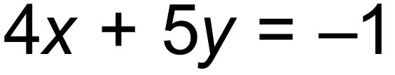 and 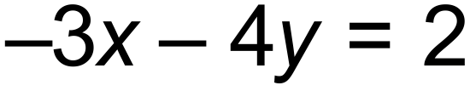
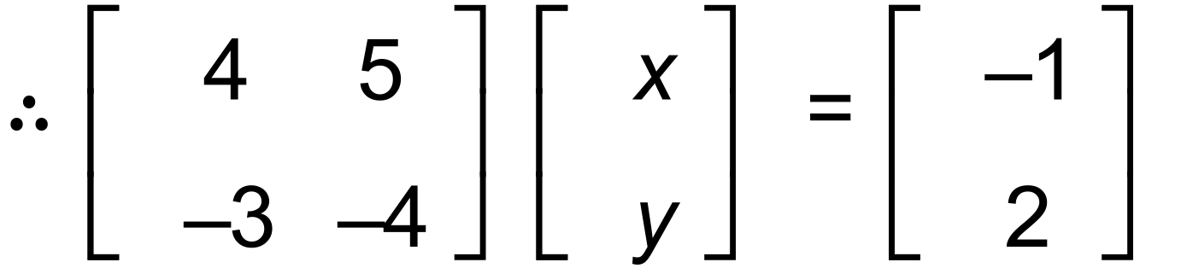 ✓
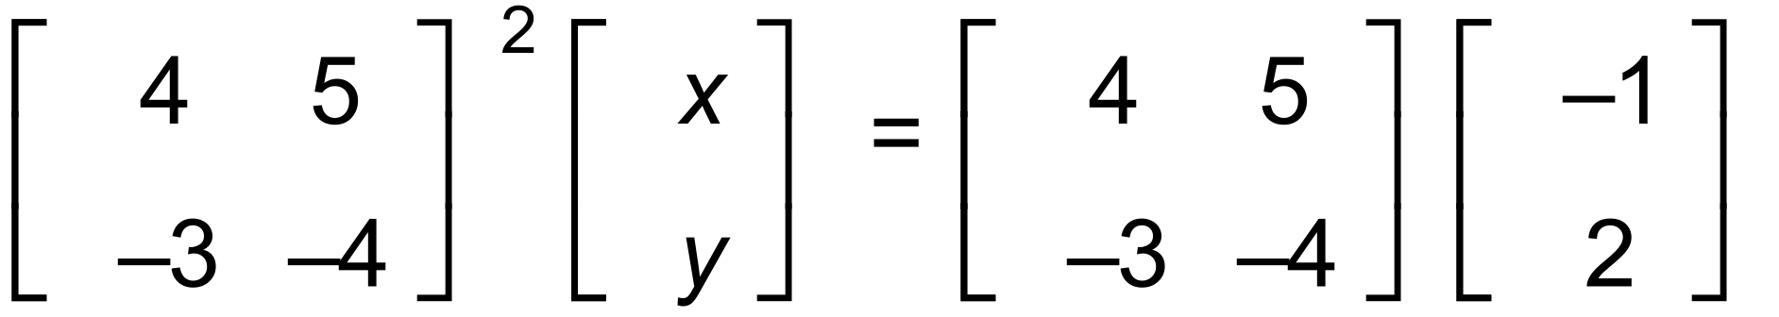 ✓
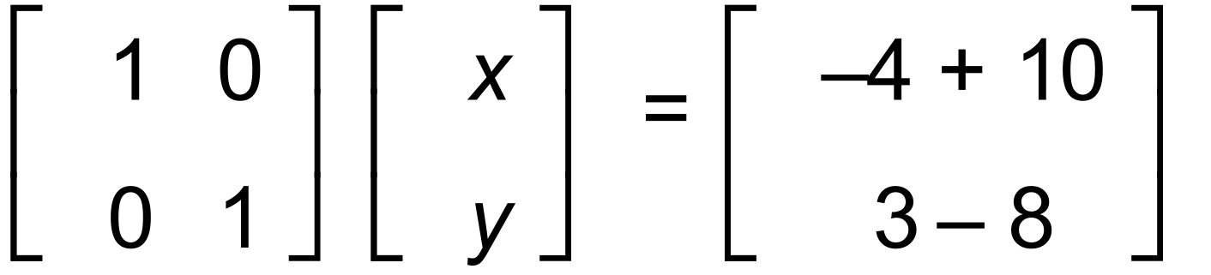
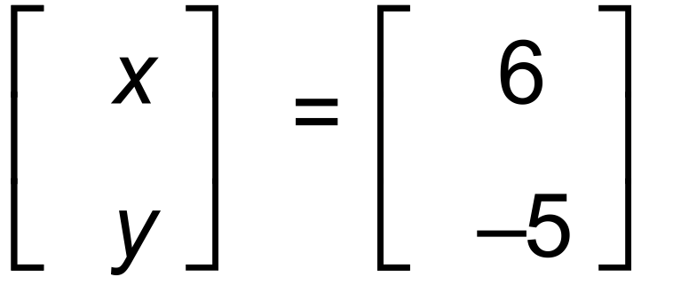 , hence 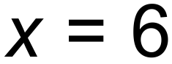 and 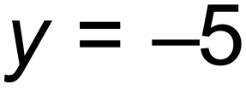 ✓

OR

(ii) for 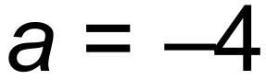, 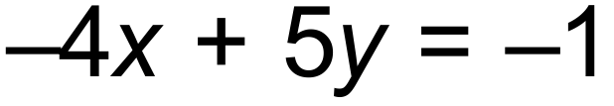 and 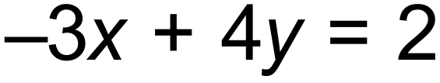
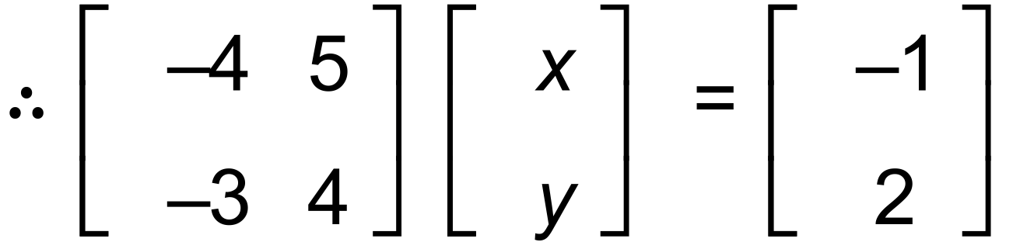 ✓
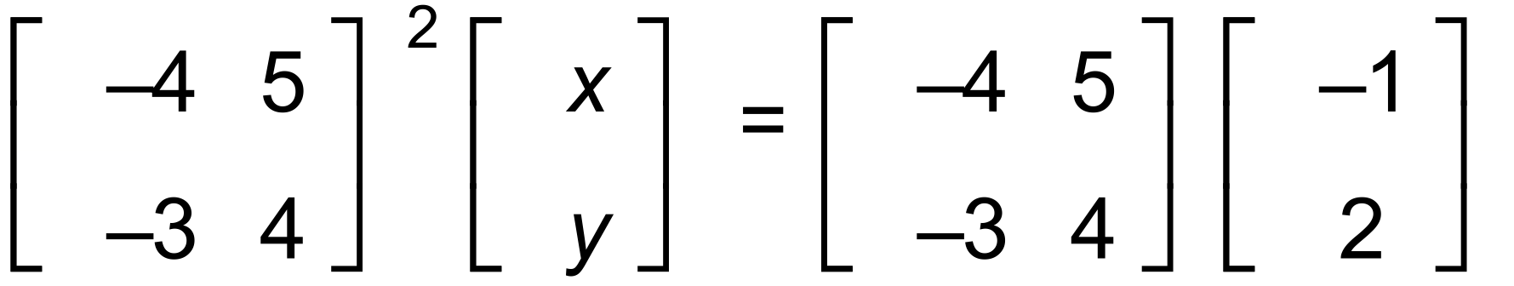 ✓
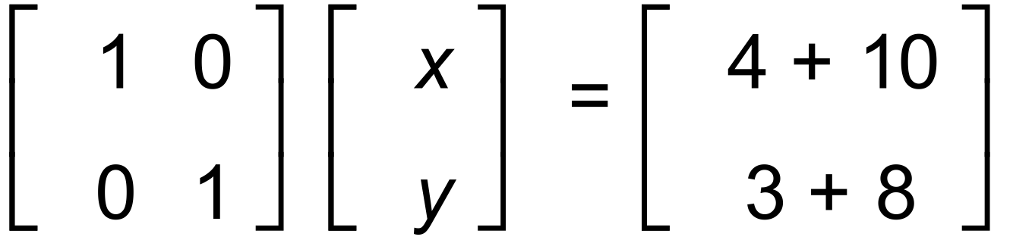
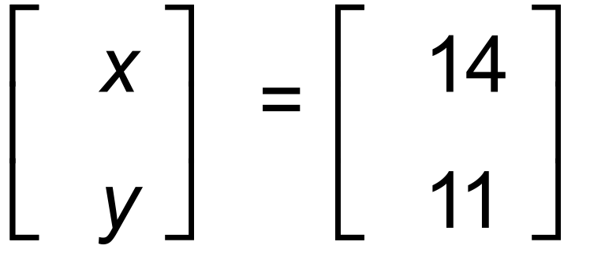 , hence 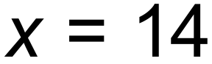 and 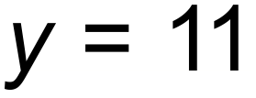 ✓

(b) (i) 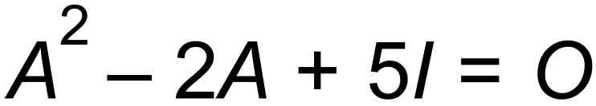
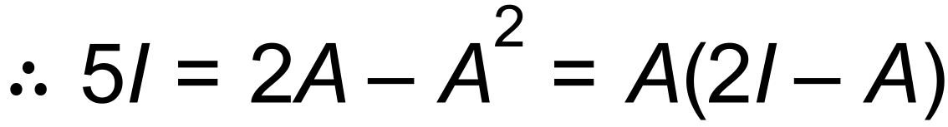 ✓✓
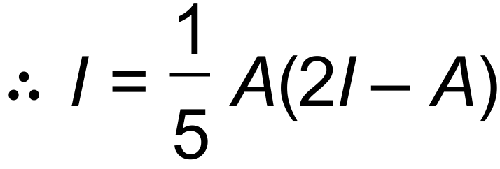 as required

(ii) 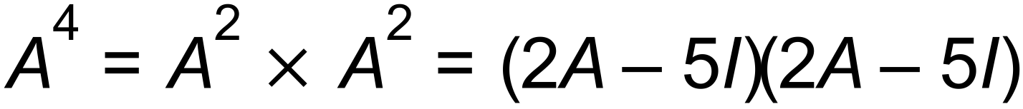 ✓
✓
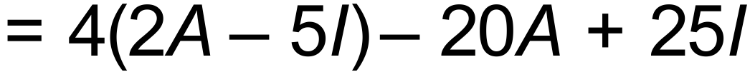 ✓
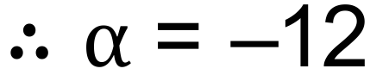 and 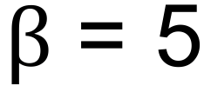 ✓ [12]

5. (a) 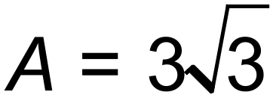 , 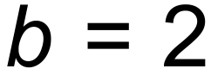 and 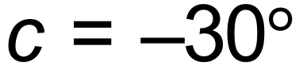 ✓✓✓
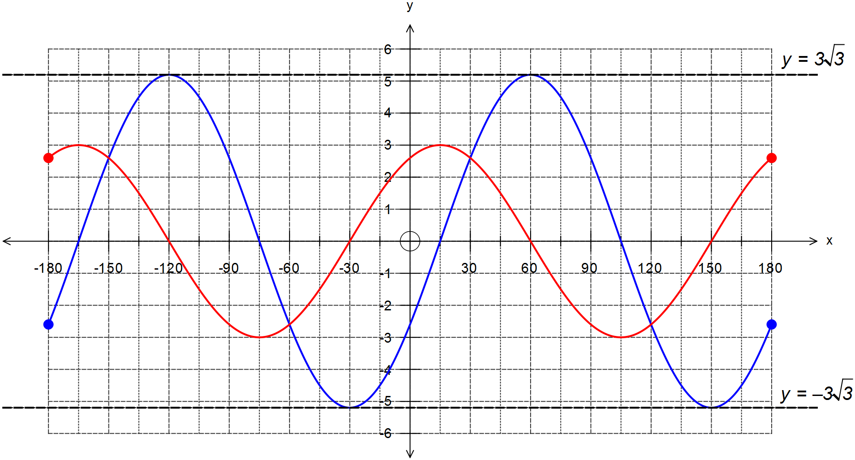 (b)

✓ cos curve with
amplitude = 3

✓ correct phase shift

✓ correct period

(c)
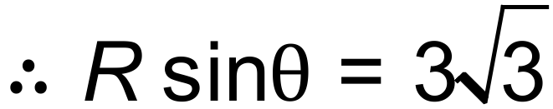 and 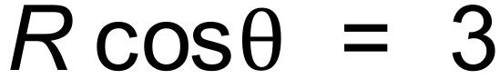 ✓✓
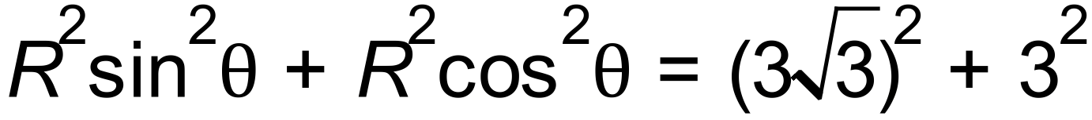
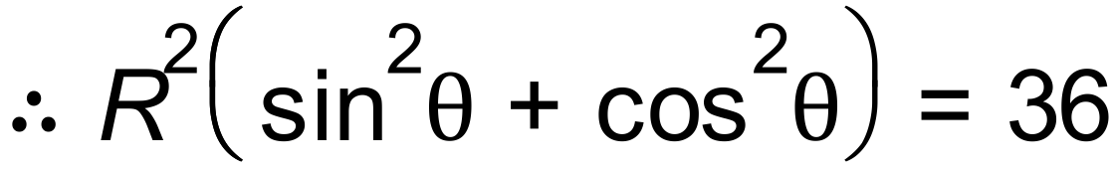 hence 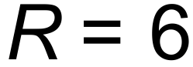 ✓
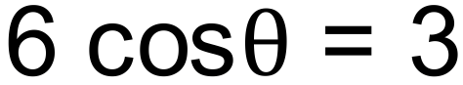 , hence 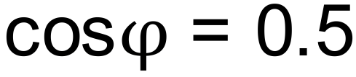 and 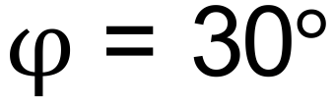 ✓

(d) 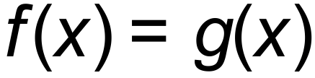 ⇒
✓✓✓✓ [14]

6. For 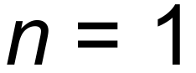: 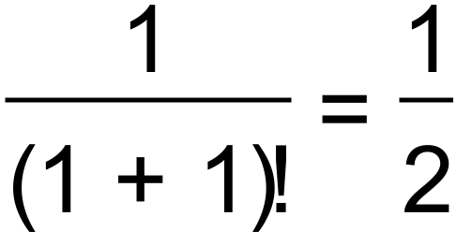 and 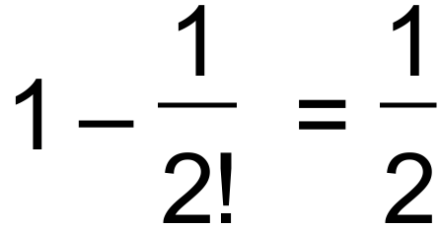.  true for ✓
Assume true for 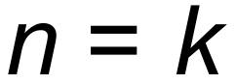:
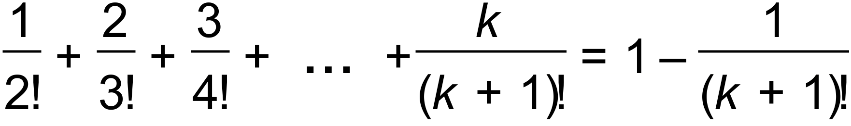 ✓
For 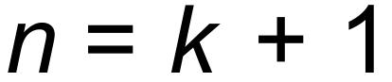:
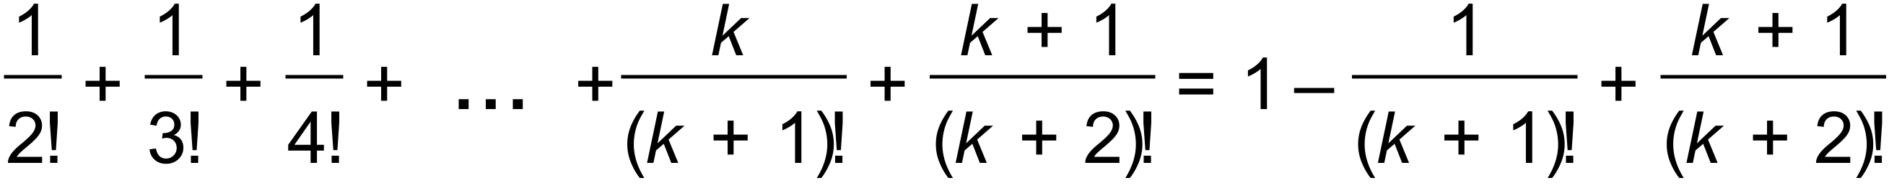 ✓✓
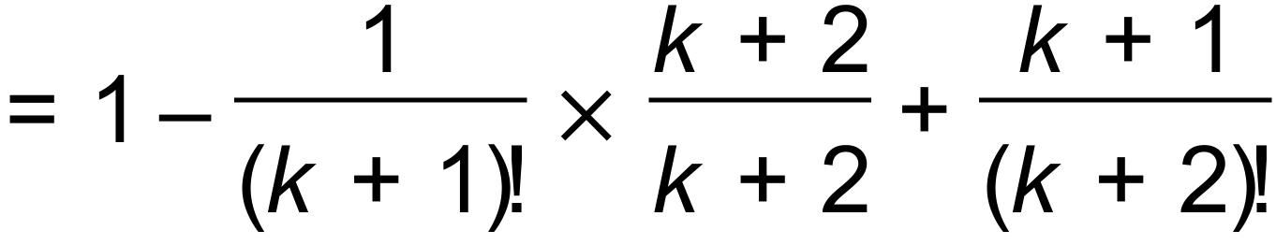
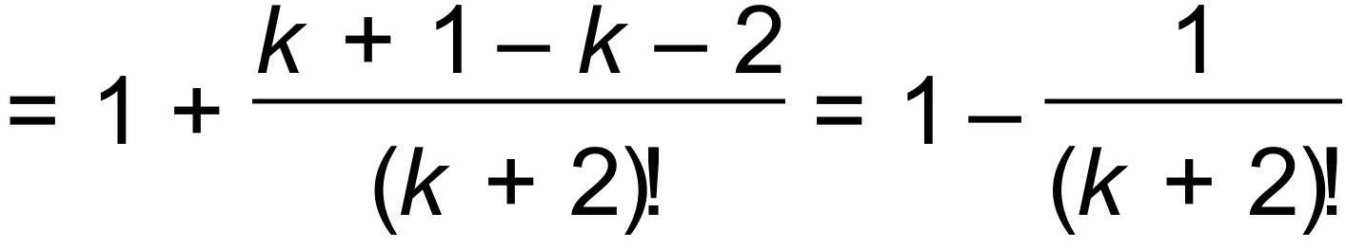 true for ✓
Therefore, since it is shown to be true for 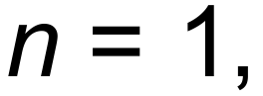 and the truth for
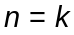 implies it is true for 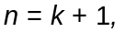 then the conjecture is true
for all positive integers 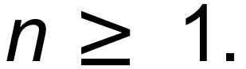 ✓ [6]

Calculator−assumed Solutions

7. Join points B and D to the centre of the circle shown below.
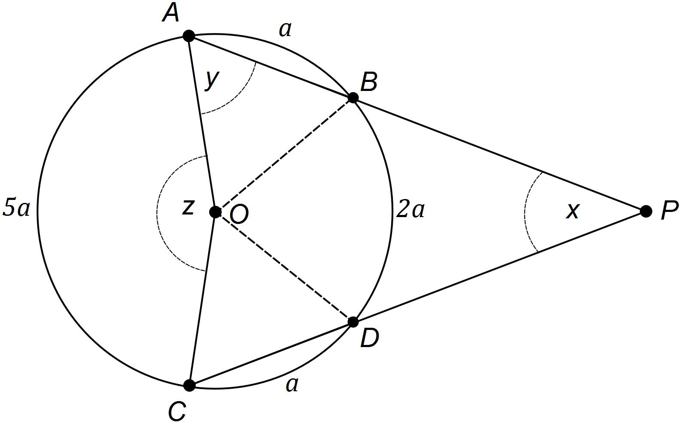

Complete circumference = 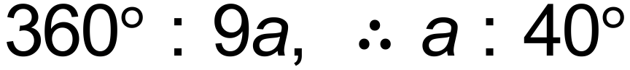 ✓
Hence, ∠AOC ✓
Also, ∠COD = ∠BOA = 40° and ΔOAB is isosceles, ✓
✓
And ∠DOB = 80°, and OBPD is a kite,
hence ∠OBP = 180° – ∠ABO = 110° ✓
✓ [6]

8. (a) 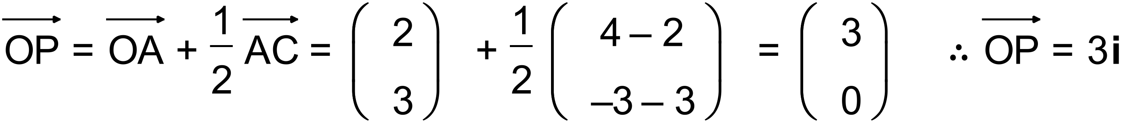 ✓✓

(b) Let Q be the midpoint of the line segment DB.
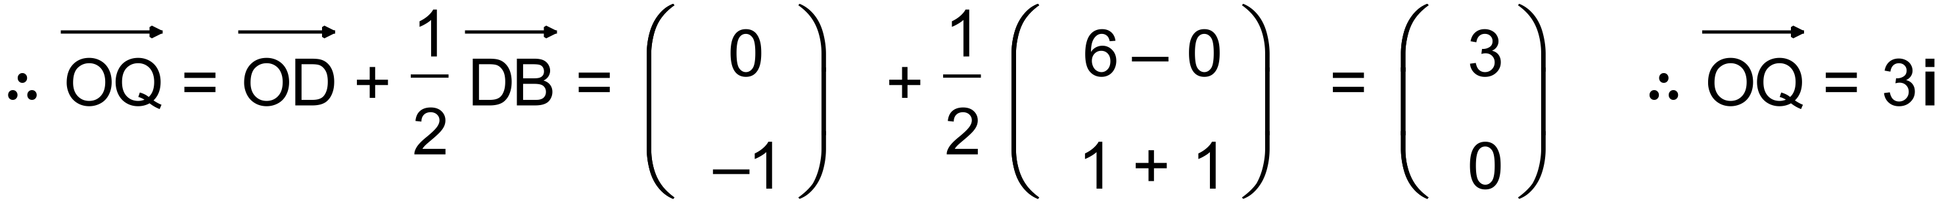 ✓✓
Since P is the midpoint of AC and Q is the midpoint of DB,
and given 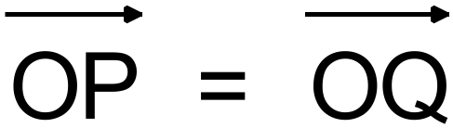, then ABCD is a parallelogram. ✓

(c) 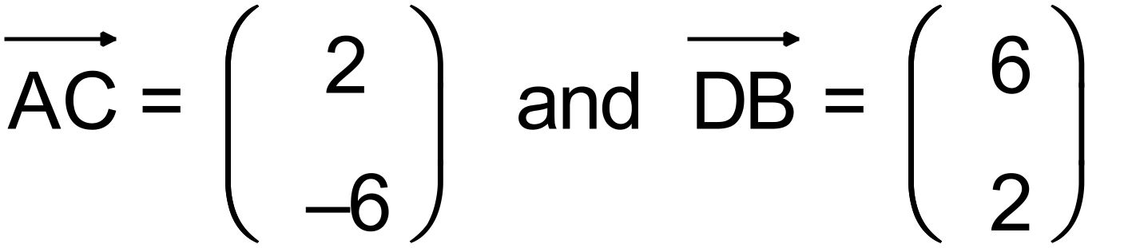
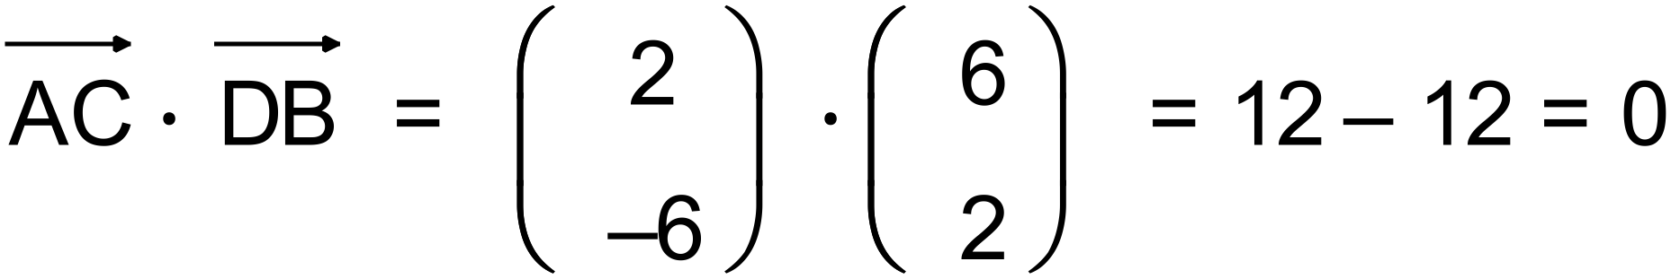 ✓
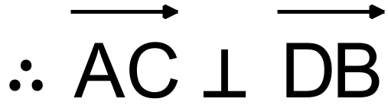 and hence ABCD is a rhombus ✓ [7]

9. 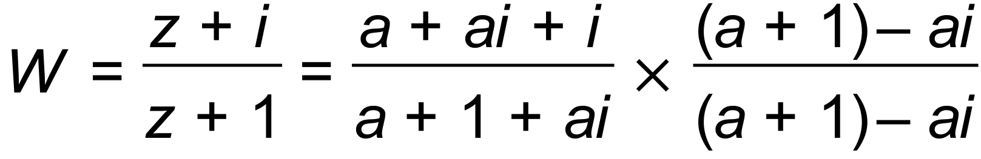 ✓
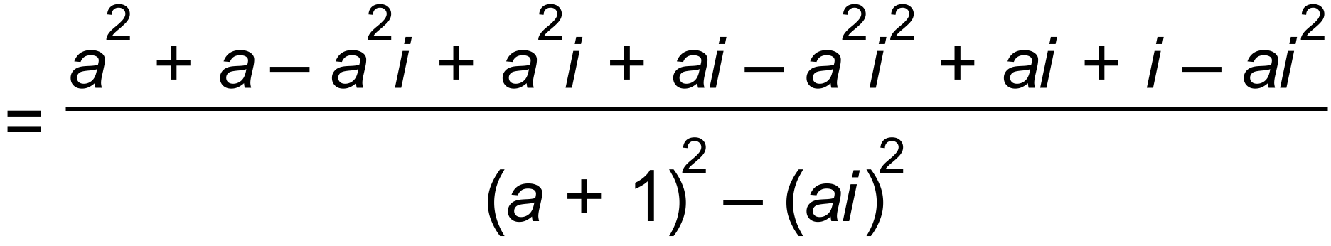
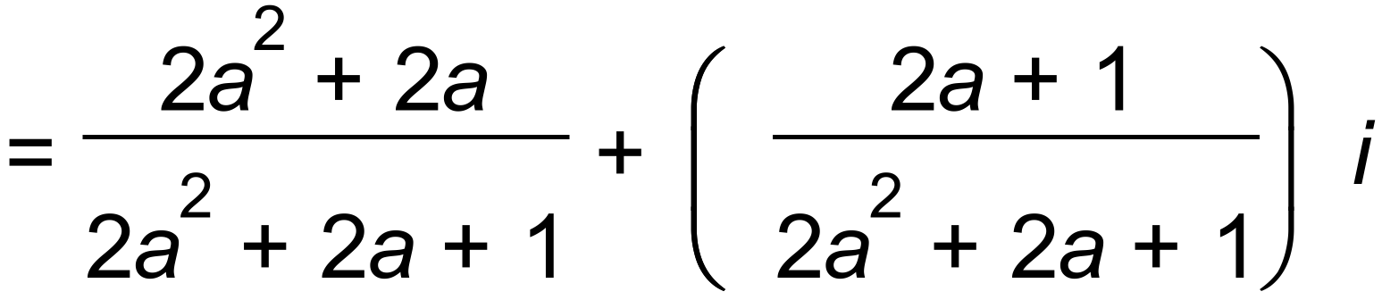 ✓✓
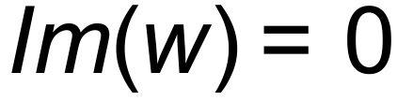 ⇒ 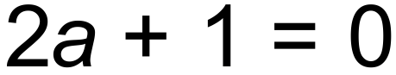 and hence 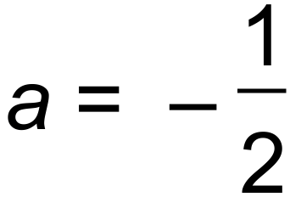 ✓
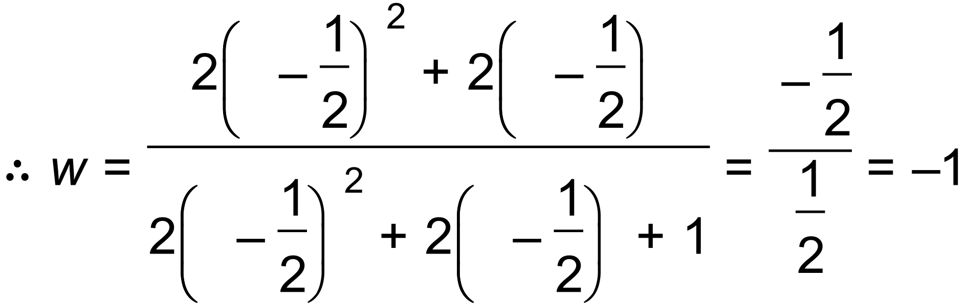 , 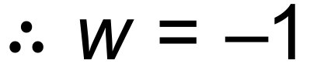 ✓ [5]

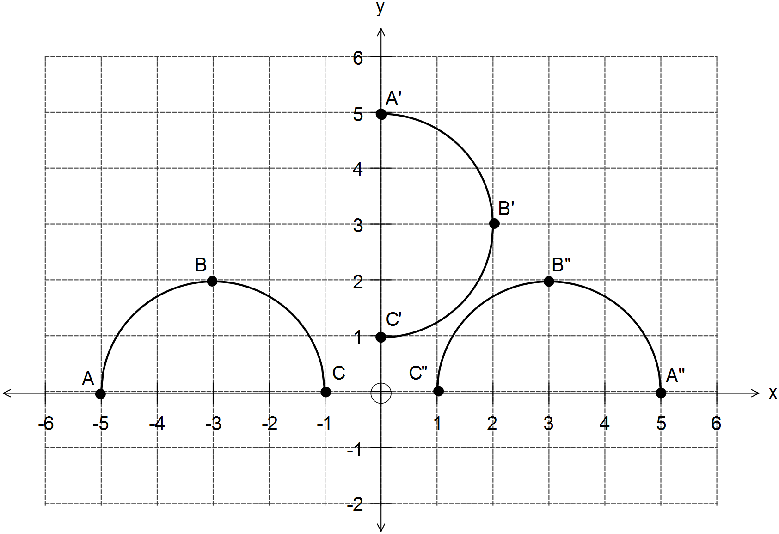10. (a) T₁ 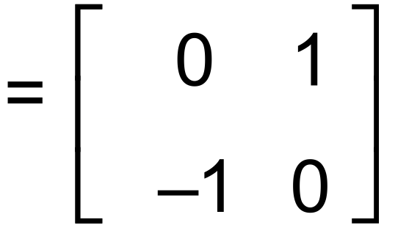 ✓

✓

(b) T₂ 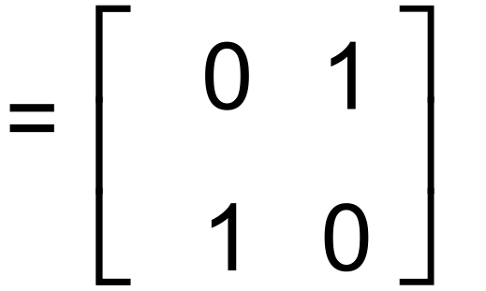 ✓
T₂ represents a reflection over the line y = x ✓✓

(c) T₂T₁ 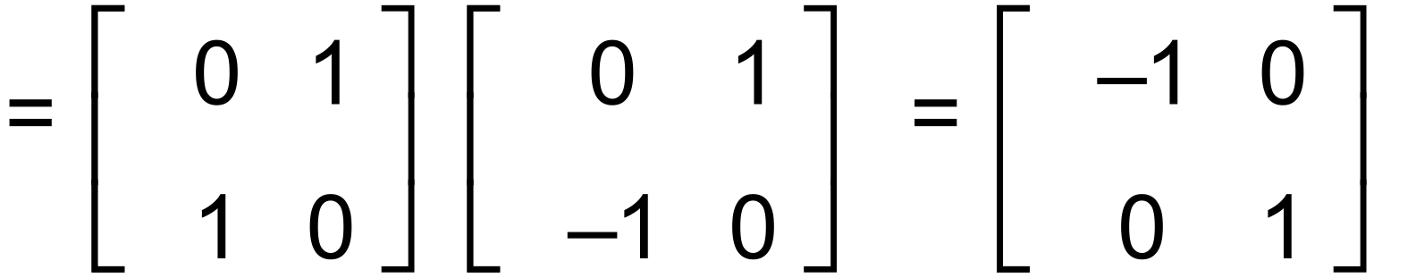 ✓✓
T₂T₁ represents a single reflection over the y axis ✓

(d) 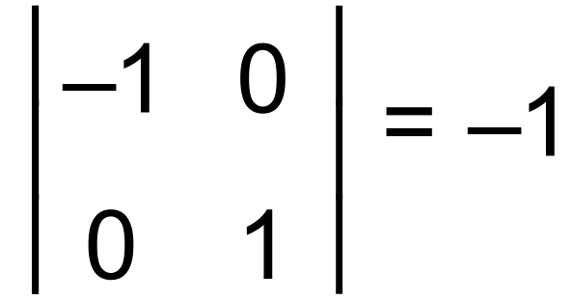 , hence |det(A)| = 1, and
Area of A’’B’’C’’ = |det(A)| × area of ABC ✓

10. (e) (T₂T₁)^{–1} = 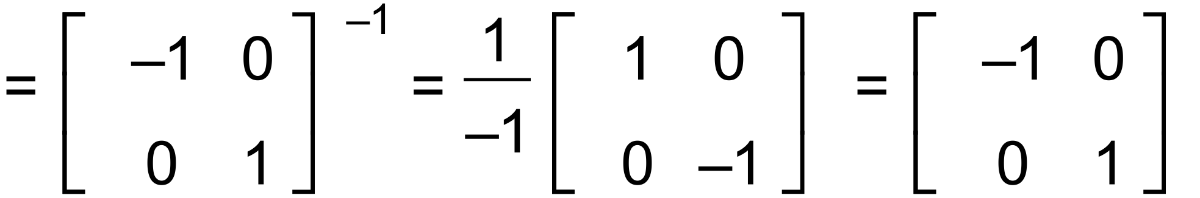 ✓✓

(f) 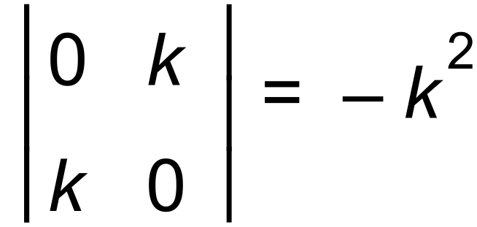 ✓
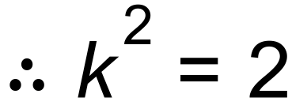 ⇒ 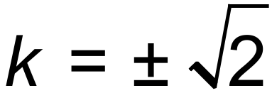 ✓ [13]

11. Equilibrium equation along the x axis:
✓
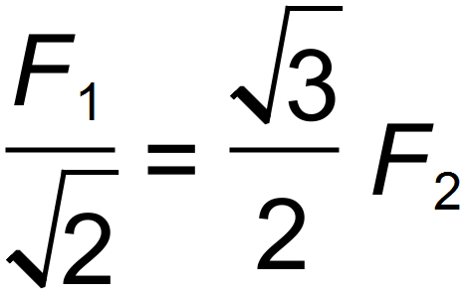 ⇒ 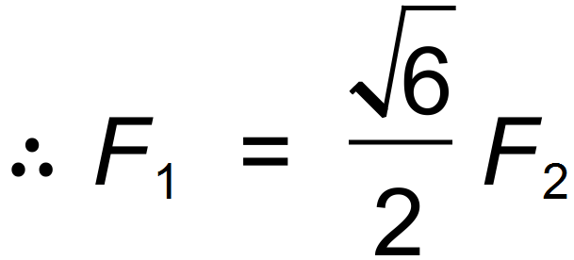 ✓
Equilibirum equation along the y axis:
✓
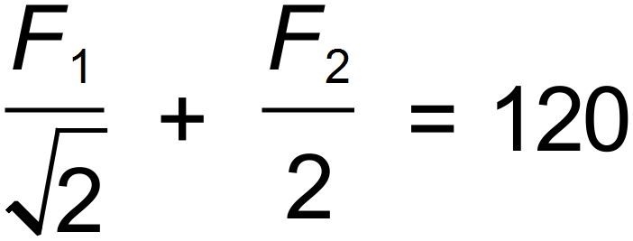 ⇒ 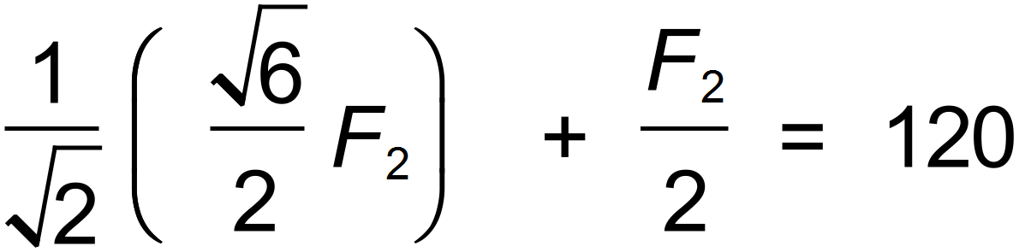
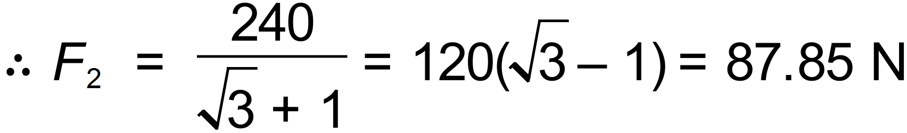 ✓
✓
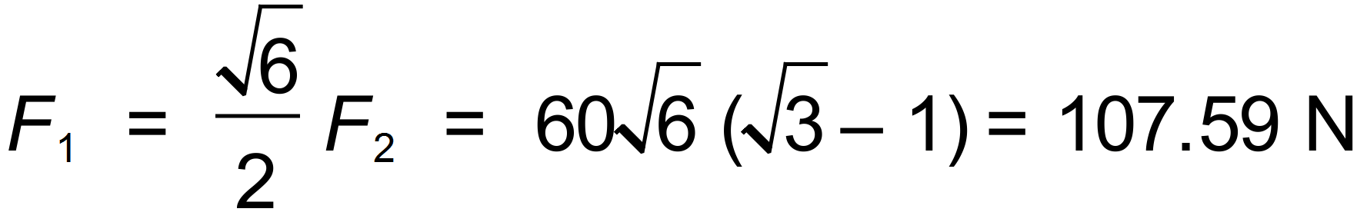 ✓
✓ [7]

A

2
5
12. (a) (i) 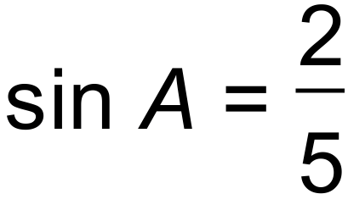 ⇒

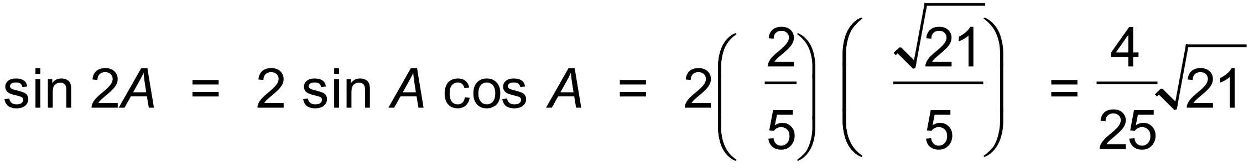 ✓✓

B

1
4
(ii) 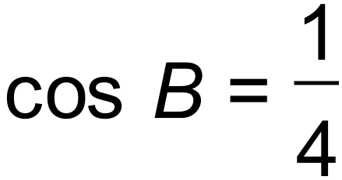 ⇒

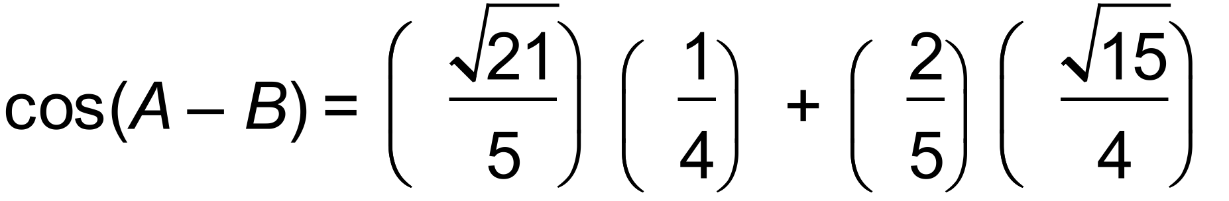 ✓✓ 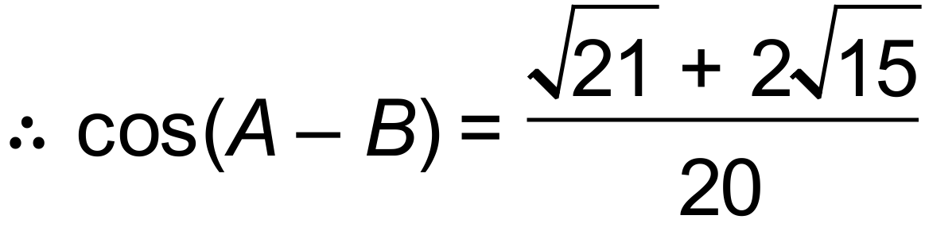 ✓

12. (a) (iii) 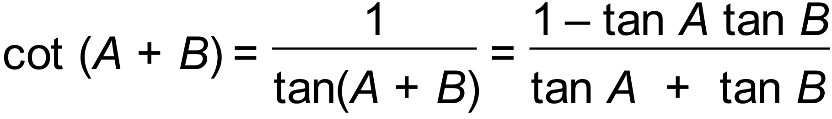 ✓
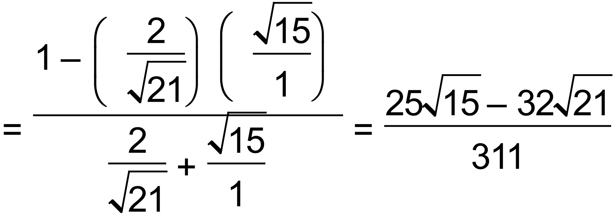 ✓✓

(b) ✓✓
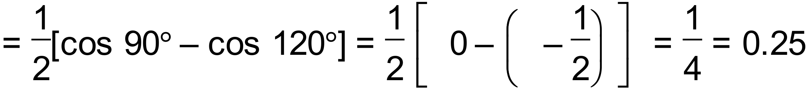 ✓

(c)
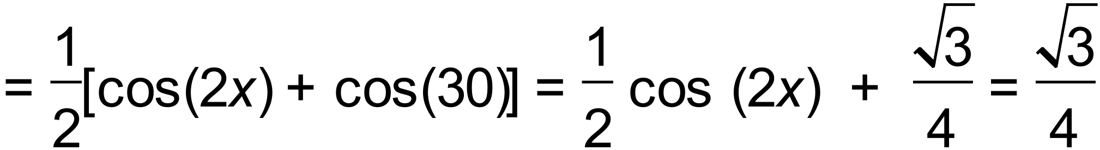 ✓✓
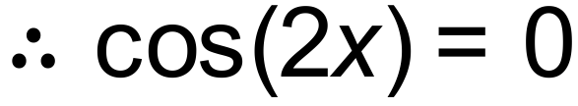 ⇒ 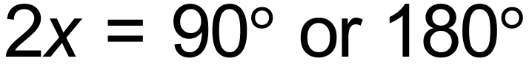
hence, 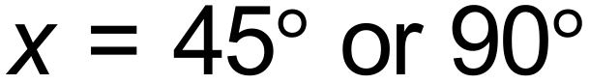 ✓✓ [15]

13. (a) Possible product combinations: ABC, BCA and CAB ✓
Resulting matrix size respectively: 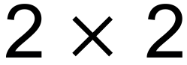, and 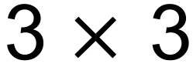 ✓

(b) 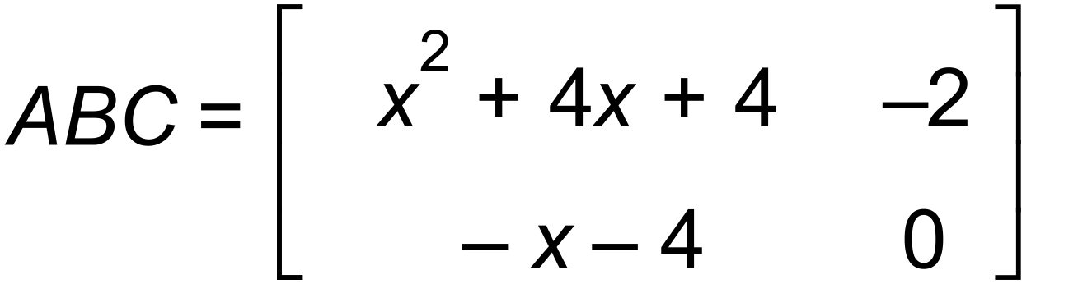 OR 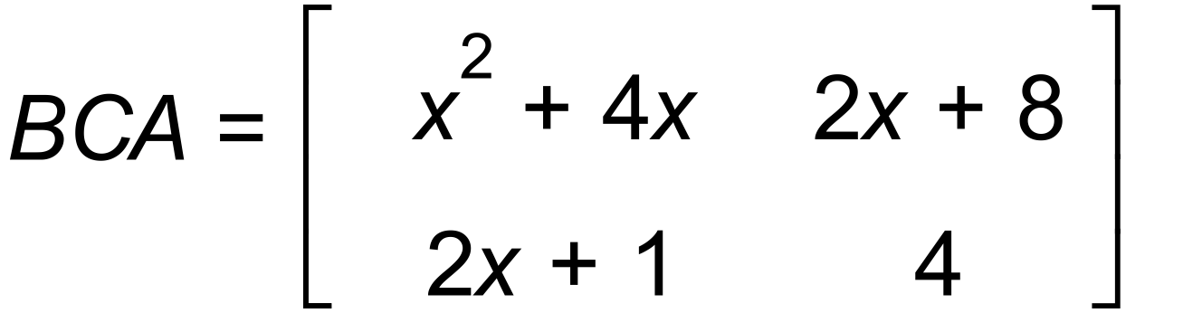 ✓✓

(c) det(ABC) = 0 → 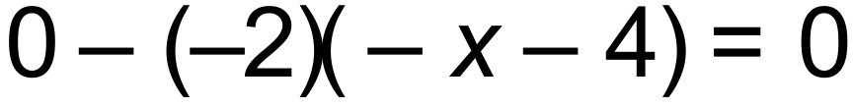 ✓✓
hence, unique solution of 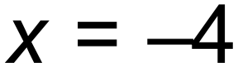 ✓
OR
det(BCA) = 0 → 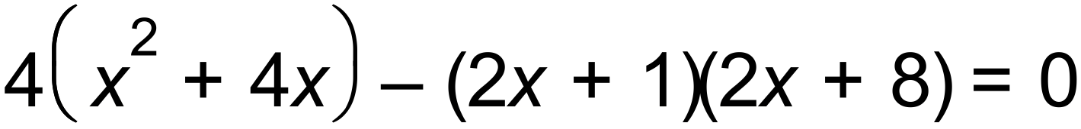 ✓✓
hence, same unique solution of ✓ [8]

14. (a) 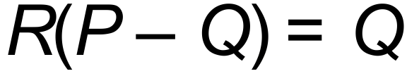
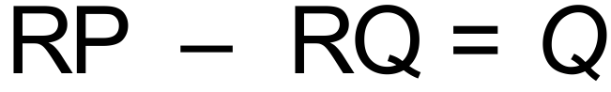
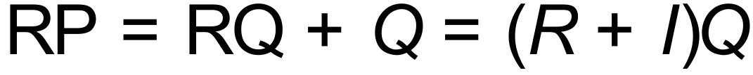 ✓
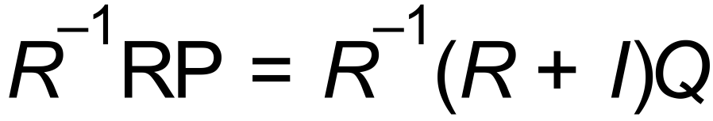 ✓
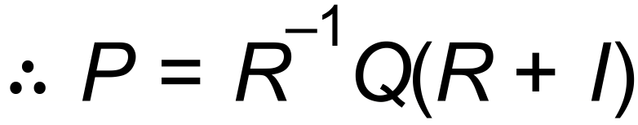 as required.

(b) 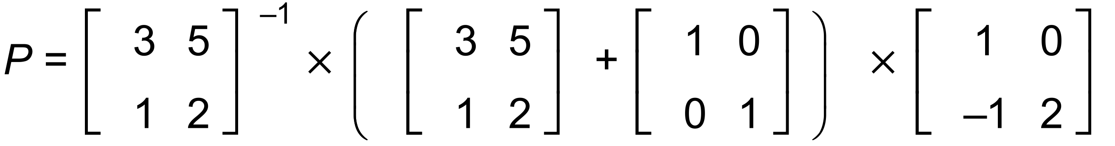
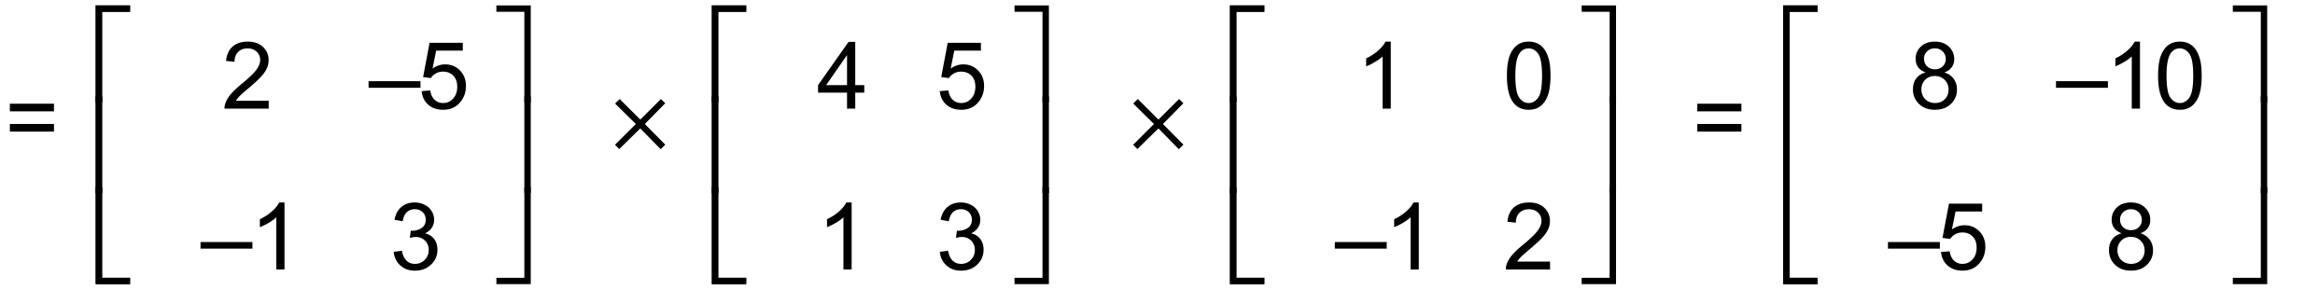 ✓✓✓ [5]
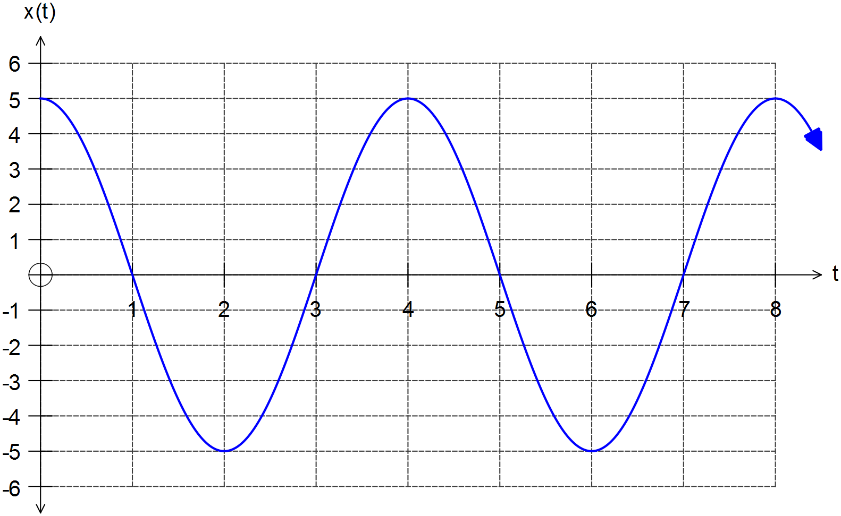15. (a)

✓ cos curve

✓ amplitude = 5

✓ period = 4 sec

(b) 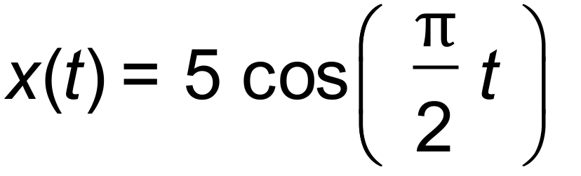 ✓✓
(c) 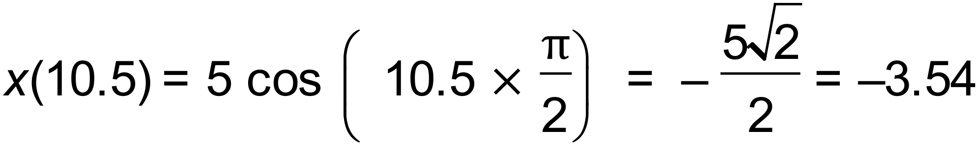 3.54 cm ✓
(d) 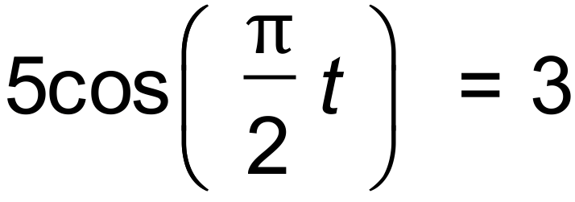 ✓
CAS → 0.59 sec ✓
(e) 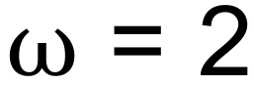 ⇒ 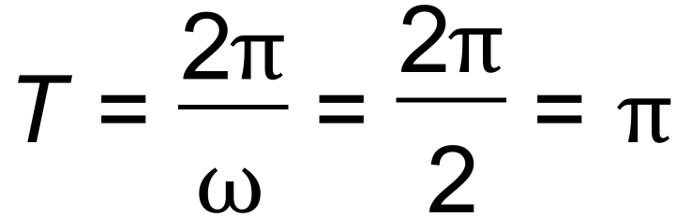 ✓
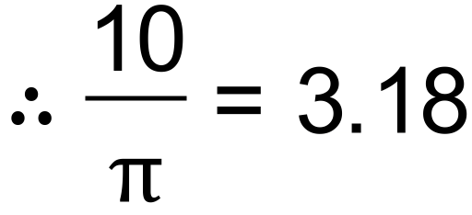 ⇒ 6 times ✓ [10]

16. (a) Let according to grid, hence
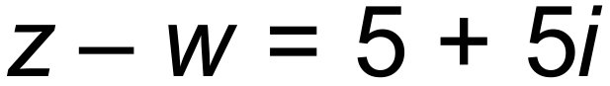 and 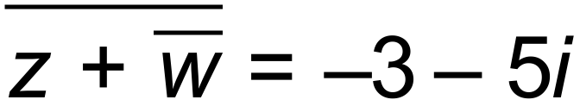
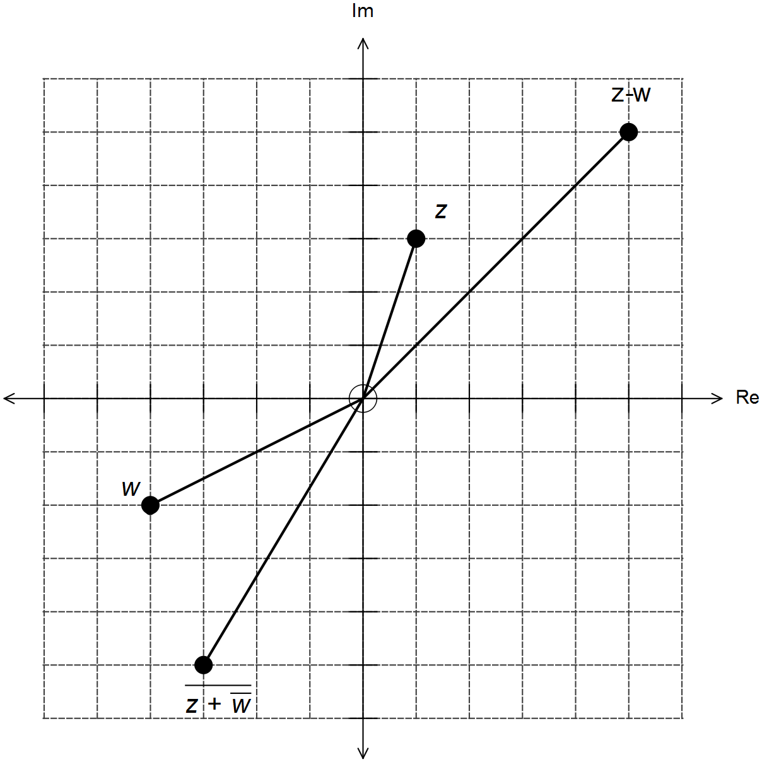

✓✓

✓✓

16. (b) 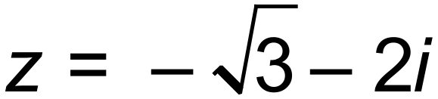 is also a solution to this equation, hence ✓
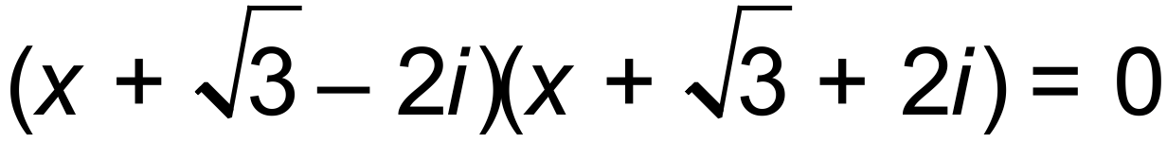 ⇒ 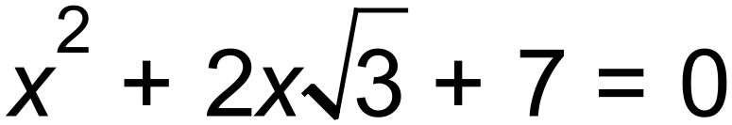
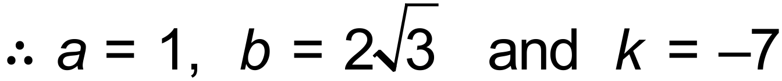 ✓✓✓

(c) (i) 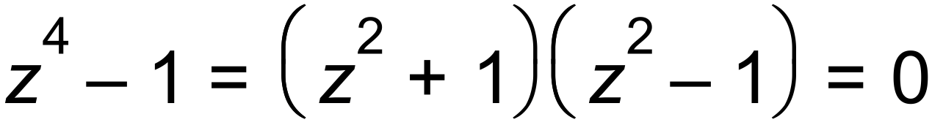 ✓
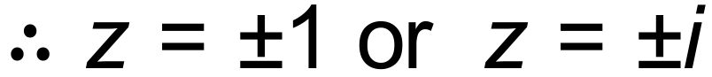 ✓✓

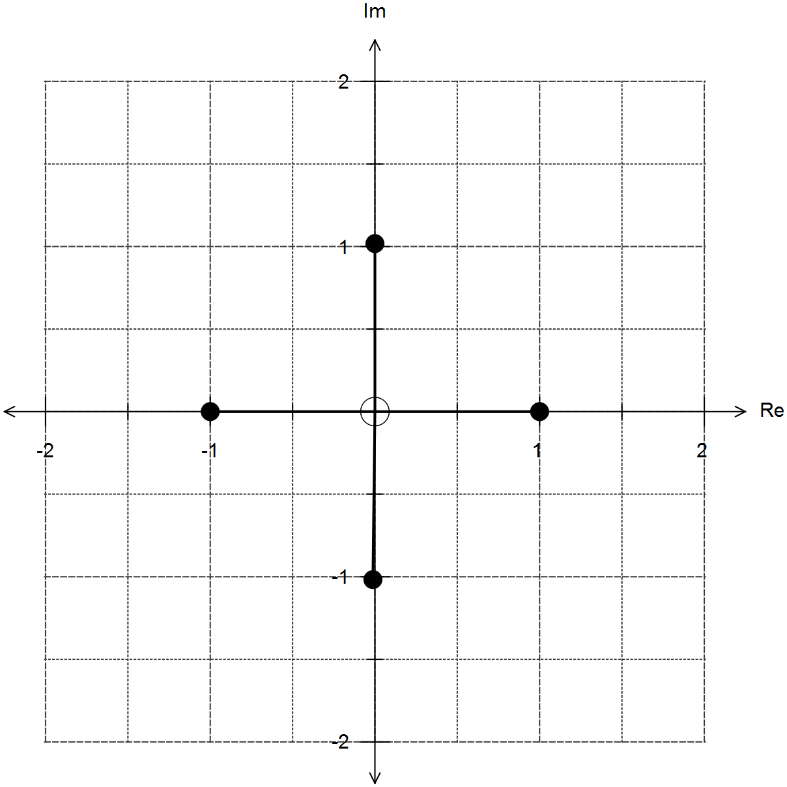 (ii)

✓✓

[13]
17. (a) Let 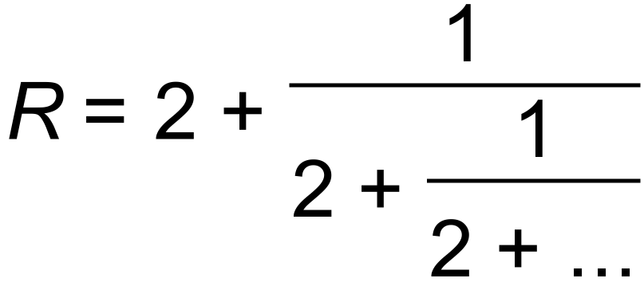 , then 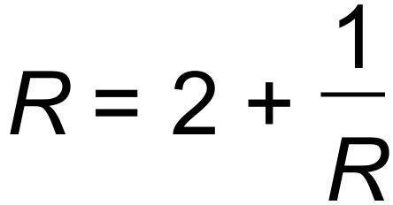 ✓
Hence, 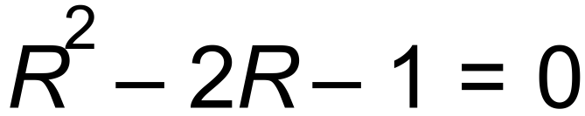 and 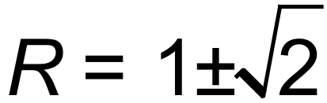 ✓
✓✓

(b) Let ✓
Then 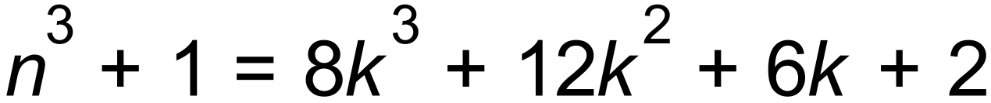 ✓
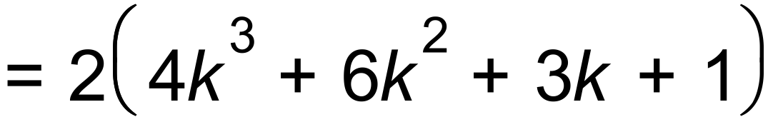
Since 2 is a factor, then 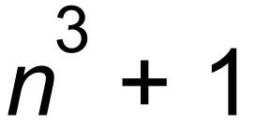 is even. ✓ [7]

18. Assume that a is not odd i.e. a is even. ✓
Then there is an integer k such that 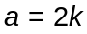 ✓
Then, = odd ✓
which is a contradiction as 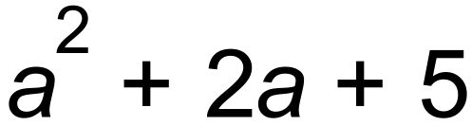 must be even.
Thefore by contradiction a must be odd. ✓ [4]

